DIXON imaging :

A T1 technique that can become T2 also !  
The Dixon technique itself is not inherently tied to T1-weighted imaging (T1WI) or T2-weighted imaging (T2WI). Instead, it is a versatile method that can be applied to both T1 and T2 weightings. The primary goal of the Dixon technique is to separate water and fat signals, which can be beneficial in either T1 or T2 imaging contexts.

#### Dixon T1WI

- **Characteristics**: T1-weighted images acquired using the Dixon technique.

- **Applications**: Useful for anatomical imaging, evaluating fatty infiltration, and assessing the overall tissue structure where T1 contrast is preferred.

#### Dixon T2WI

- **Characteristics**: T2-weighted images acquired using the Dixon technique.

- **Applications**: Useful for identifying fluid-filled structures, edema, and other pathological conditions where T2 contrast is beneficial.

### How Dixon Works with T1WI and T2WI

- **T1-Weighted Dixon Imaging**: The sequence parameters are adjusted to provide T1 contrast, and the Dixon technique is used to separate water and fat signals, creating in-phase and opposed-phase images that are T1-weighted.

- **T2-Weighted Dixon Imaging**: The sequence parameters are adjusted to provide T2 contrast, and the Dixon technique similarly separates water and fat signals, but the resultant in-phase and opposed-phase images are T2-weighted.

### Summary

The Dixon technique can be used with both T1 and T2 weightings, enhancing the ability to differentiate between fat and water in various tissues. The choice of weighting (T1 or T2) depends on the specific clinical application and the type of tissue contrast needed for diagnosis.

### Detailed Explanation of the Dixon Technique in MRI

The Dixon technique is a method in MRI that leverages the difference in precession frequencies between water and fat molecules to separate their signals, leading to enhanced image quality and diagnostic capability.

#### Fundamental Concept

- **Precession Rates**: Water and fat molecules in the body have different magnetic properties, causing them to precess (rotate around the magnetic field axis) at slightly different rates.

- **In-Phase and Opposed-Phase**: At specific times during the MRI acquisition, the signals from water and fat molecules can either add together (in-phase) or subtract from each other (opposed-phase).

#### Image Acquisition and Processing

1. **In-Phase (IP) Image**: Captured when water and fat signals are in sync, resulting in a combined signal.

- **Formula**: IP = (Water + Fat)

2. **Opposed-Phase (OP) Image**: Captured when water and fat signals are out of sync, resulting in their difference.

- **Formula**: OP = (Water - Fat)

By capturing these two types of images, the Dixon technique allows for mathematical manipulation to generate specific tissue contrasts:

3. **Fat-Only Image**:

- **Calculation**: Subtract the opposed-phase image from the in-phase image.

- **Formula**: Fat Only = IP - OP = (Water + Fat) - (Water - Fat) = 2 * Fat

- **Purpose**: Visualizes fat content within tissues, useful for identifying fatty infiltration, lipomas, and assessing fat distribution.

4. **Water-Only Image**:

- **Calculation**: Add the in-phase image to the opposed-phase image.

- **Formula**: Water Only = IP + OP = (Water + Fat) + (Water - Fat) = 2 * Water

- **Purpose**: Highlights water-containing tissues, effectively suppressing the fat signal, useful for evaluating edema, inflammation, and other conditions with significant water content.

#### Practical Applications

- **Fat-Suppressed Imaging**: The water-only image functions as a fat-suppressed image, enhancing the visibility of water-dominant tissues while suppressing the fat signal.

- **Quantification and Fat Suppression**: The fat-only image can be used to quantify fat content in tissues and can be combined with other MRI sequences of various weightings to achieve fat suppression in images, improving the contrast and diagnostic quality.

### Summary

The Dixon technique enhances MRI by separating water and fat signals through in-phase and opposed-phase imaging. This separation is achieved via mathematical combination of the acquired images, resulting in fat-only and water-only sequences, which significantly improve the ability to visualize and quantify different tissue components.

- **In-Phase (IP)**: (Water + Fat)

- **Opposed-Phase (OP)**: (Water - Fat)

- **Fat Only**: IP - OP = 2 * Fat

- **Water Only**: IP + OP = 2 * Water

This method is widely used for improving diagnostic accuracy in various clinical scenarios, particularly in liver imaging, musculoskeletal assessments, and body composition analysis.

DIXON:

In Phase: (acts like T2WI)  
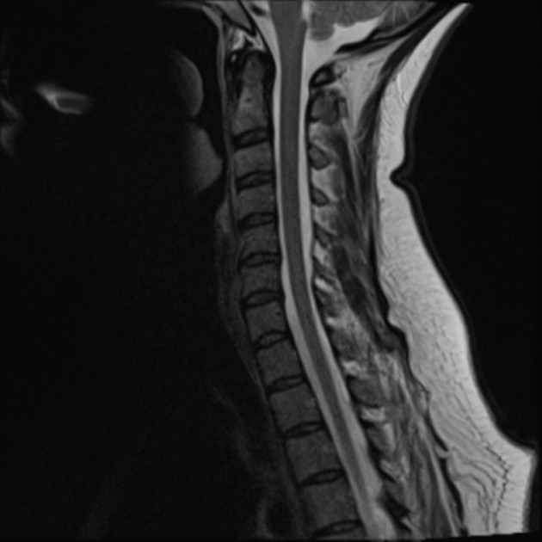

Out phase Phase: (acts like T2FS W)

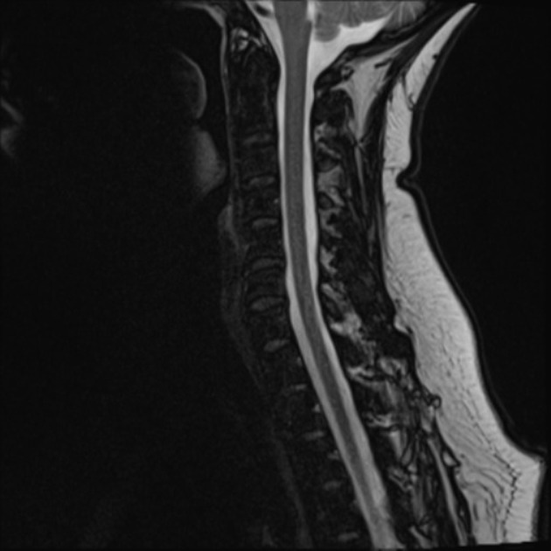

DIXON water (inphase +

